Appendix A - User Manual

# Setting up the environment:

## How to clone the project

In the Azure DevOps website. You must be granted access to be able to view the projects.

After signing in you will have access to two projects

Gamification and Gamification.Service

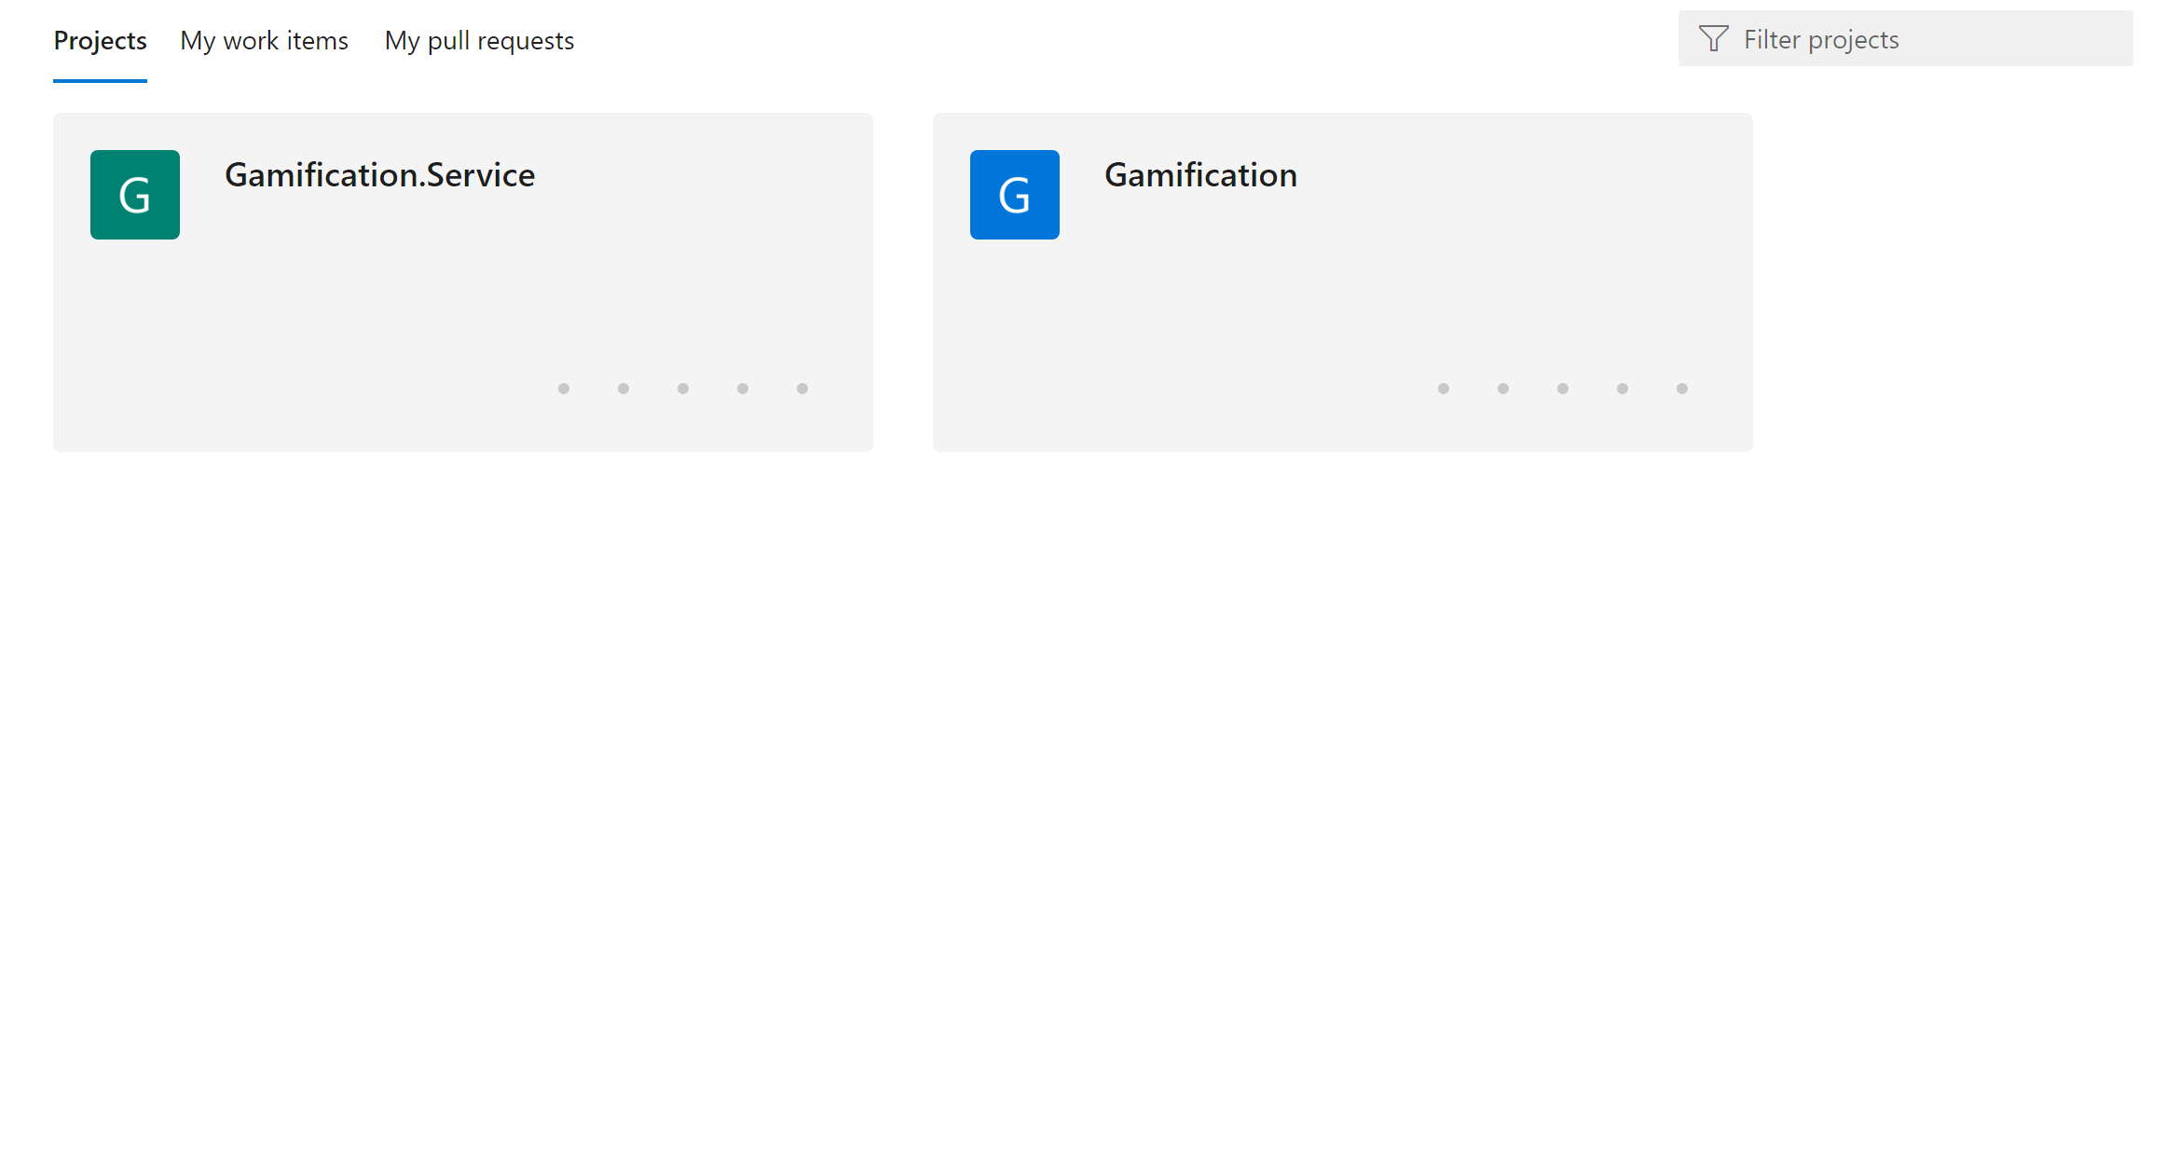

You then clone the two projects to the same local repository.

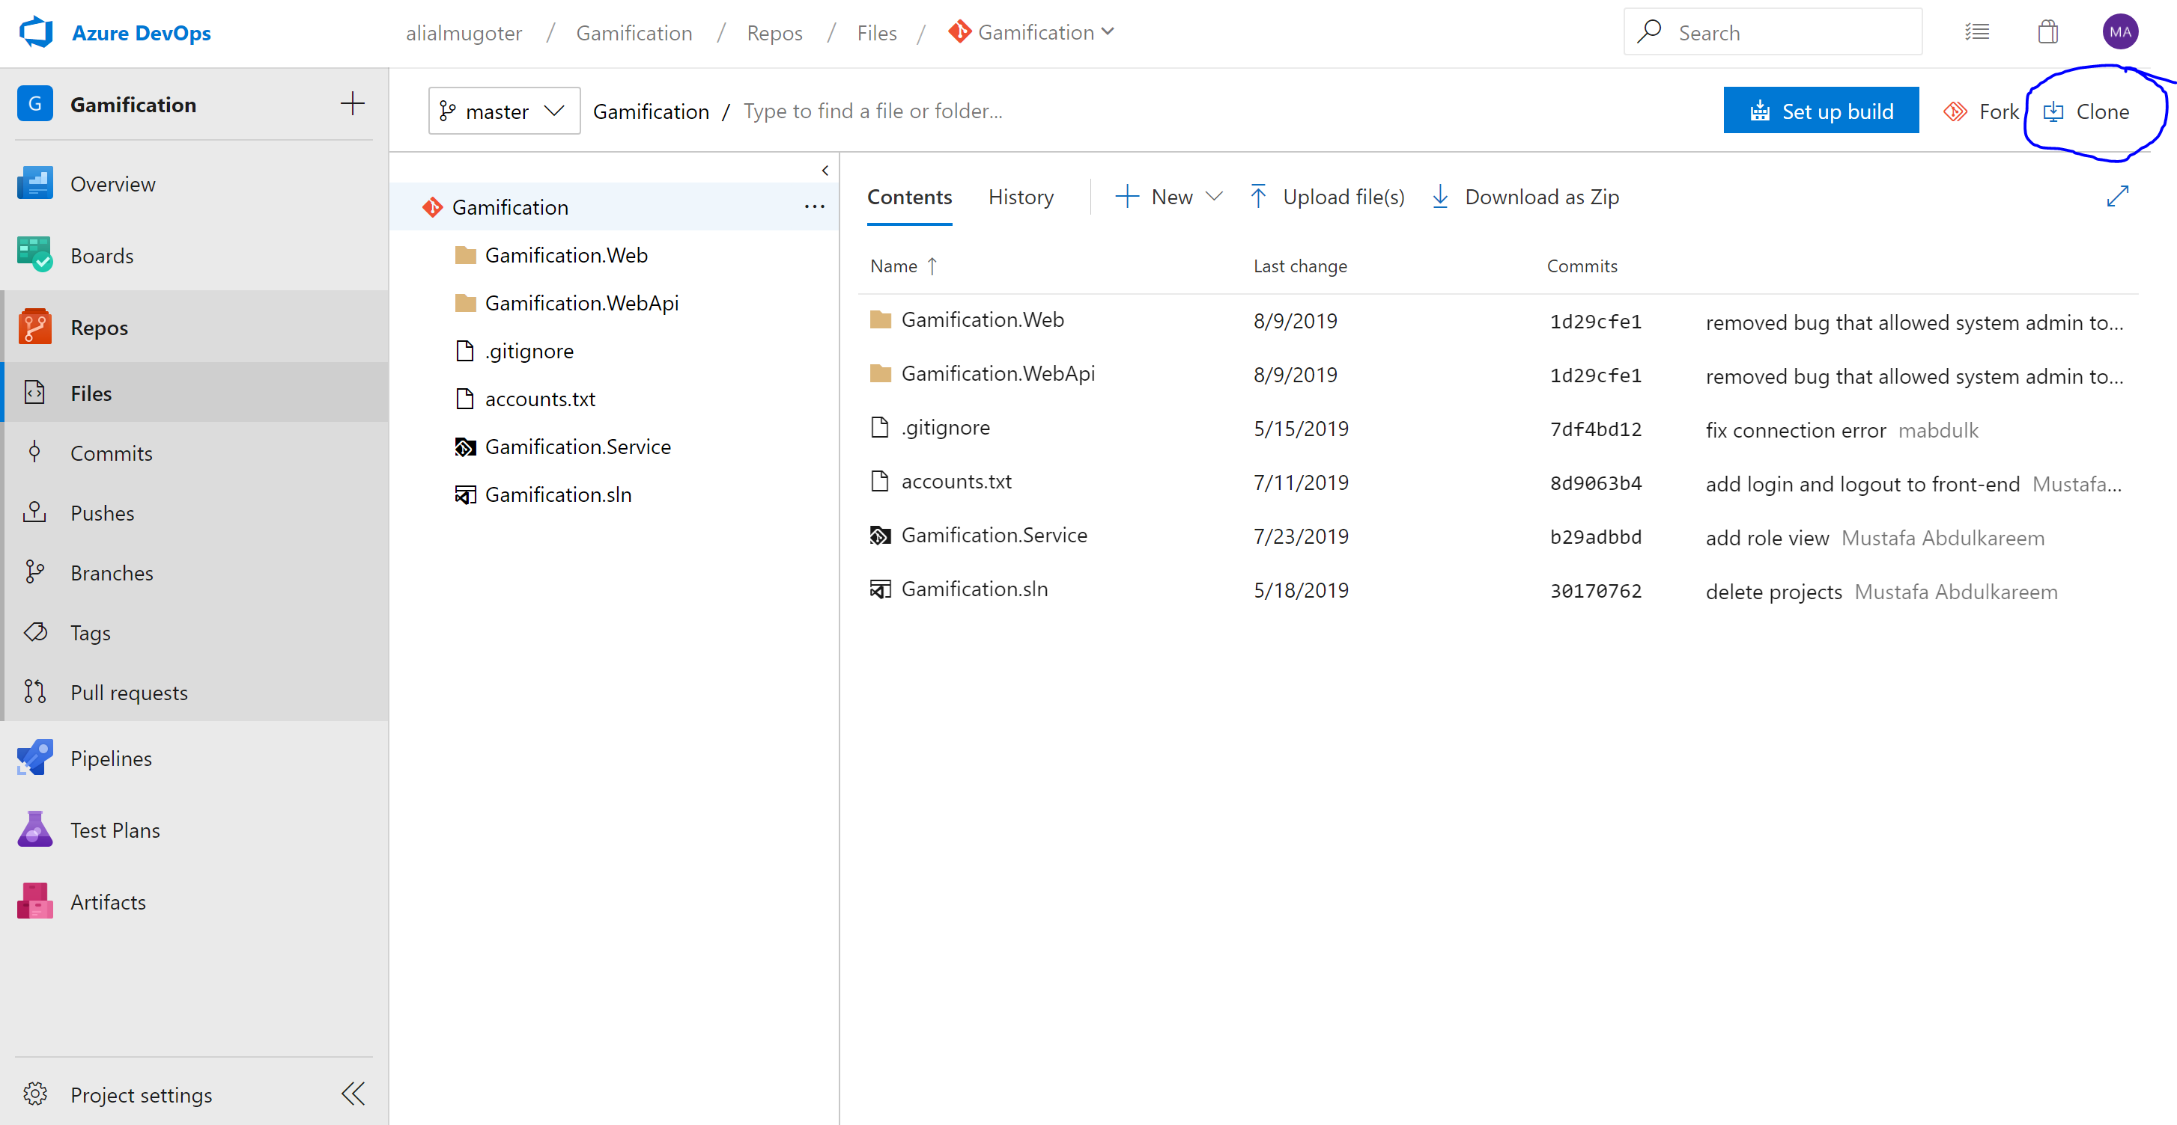

## What tools you need

* Visual Studio
* Visual Studio Code
* Microsoft SQL Server Management Studio

Gamification: you open visual studio and get to the directory Gamification and select Gamification.sln

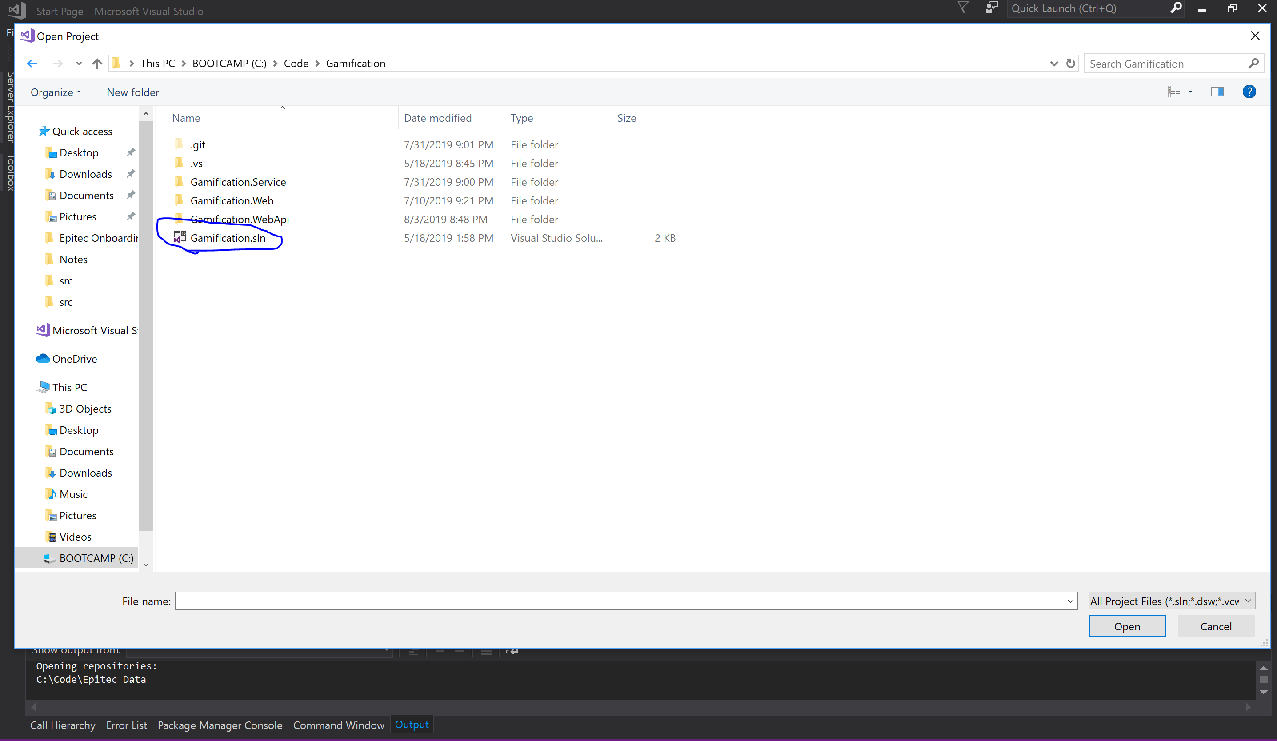

this will open the project solution for you. It contains the backend of the project (web api .net core). When you run the project you should see the browser opening with the local port number.

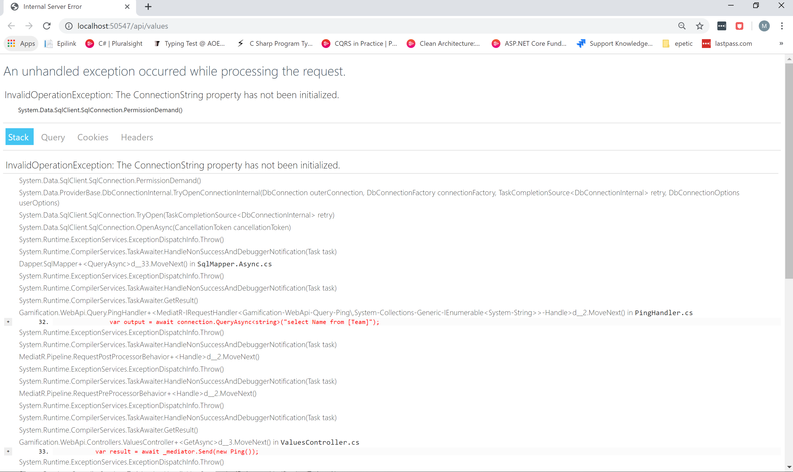

FrontEnd: to run the front-end you first open Visual Studio Code, you select the following folder to open (Gamification.Web)

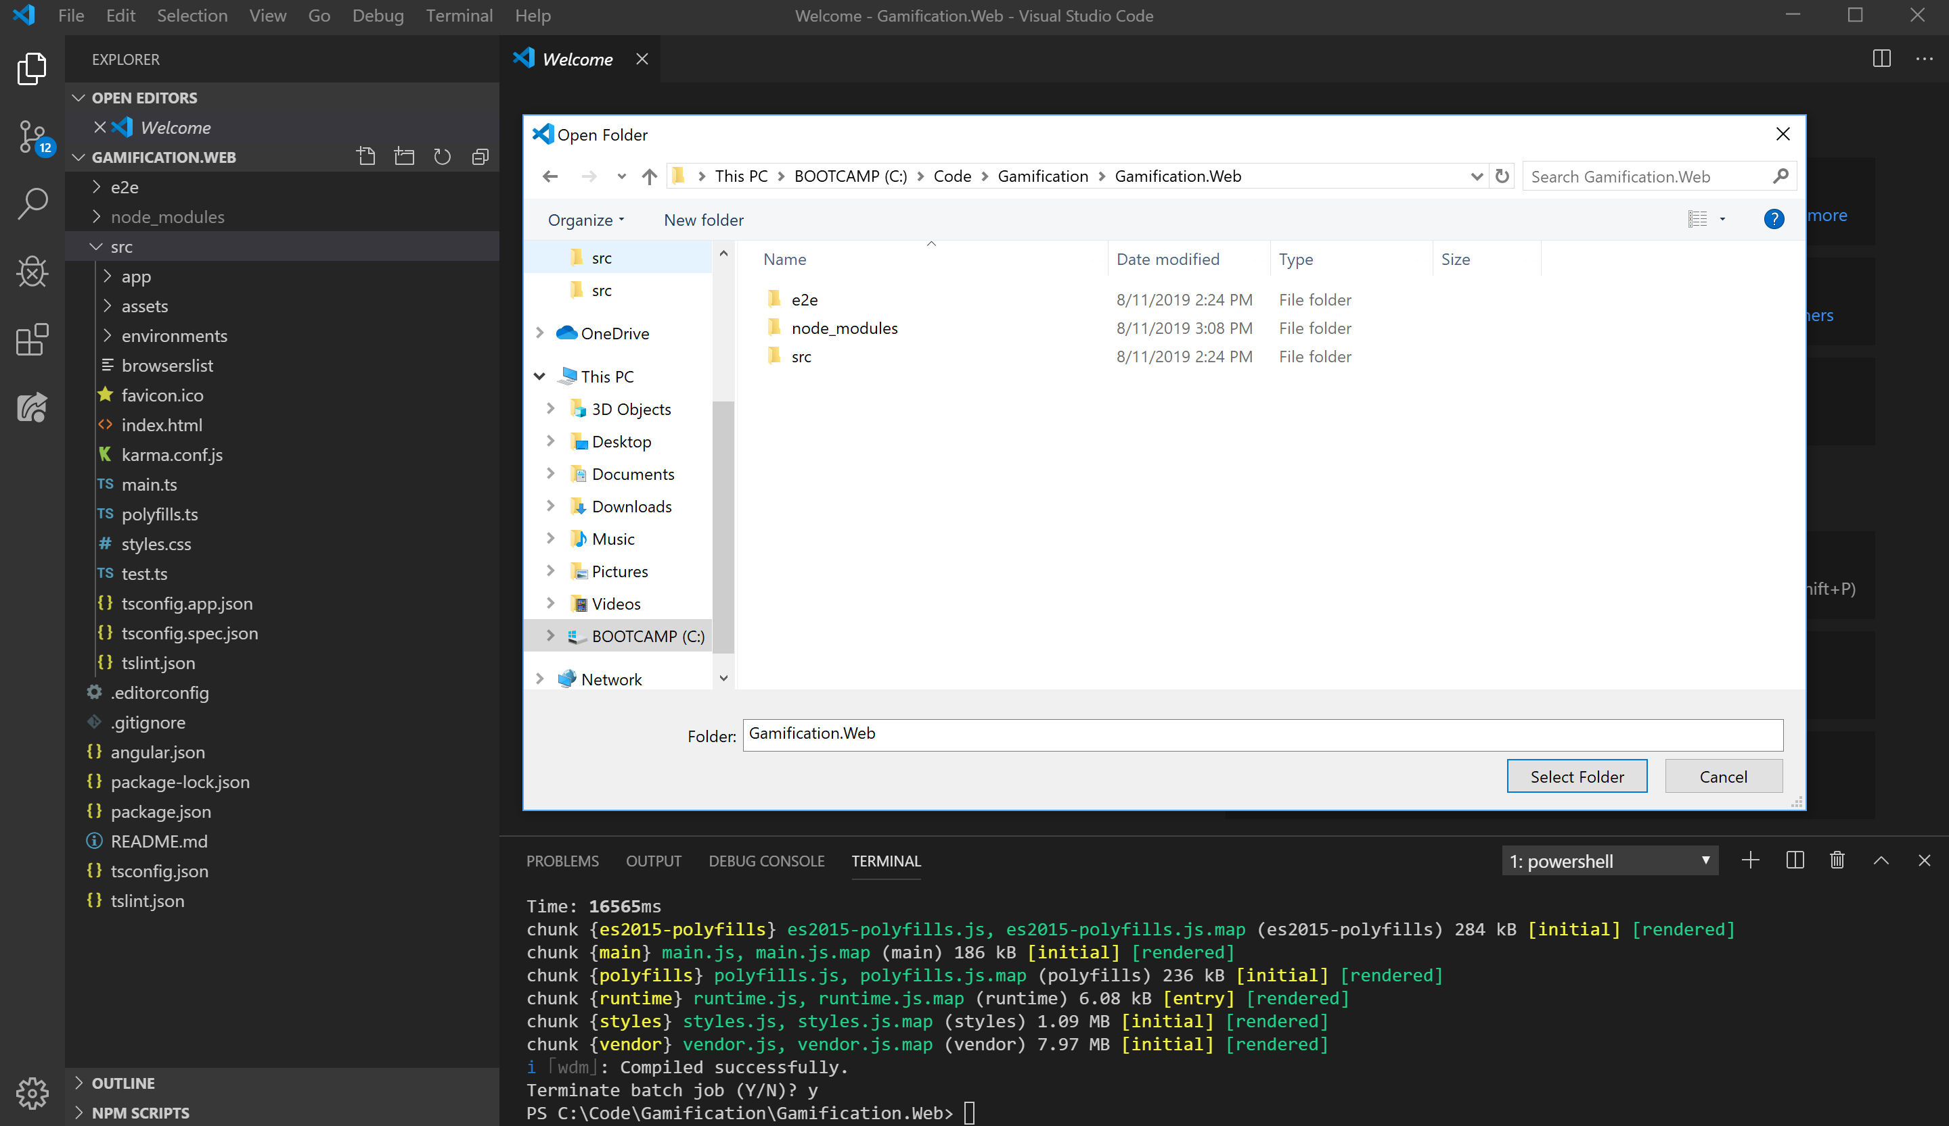

After selecting the folder you open the terminal command and run the following command

Npm install

//this will install the Nuget package

Npm start

// this will run the front-end

Then you type in [http://localhost:4200](http://localhost:4200/) in the browser to view the website

